Yao Yijiang

Li Si

ECE110

April 4, 2023

Unit report 2

1 Back-EMF suppression of the motor by using a diode

There is a significant voltage spike when the MOSFET is rapidly turned off, the sudden suppression of current flow through the inductive load induces a voltage spike due to the inductor’s property of resisting changes in current.

The windings of the motor act as an inductor, storing energy in a magnetic field as current flows through it. When the current drive is suddenly suppressed, the stored field energy resists the sudden change, resulting in a high spike in voltage.

The result is like this:

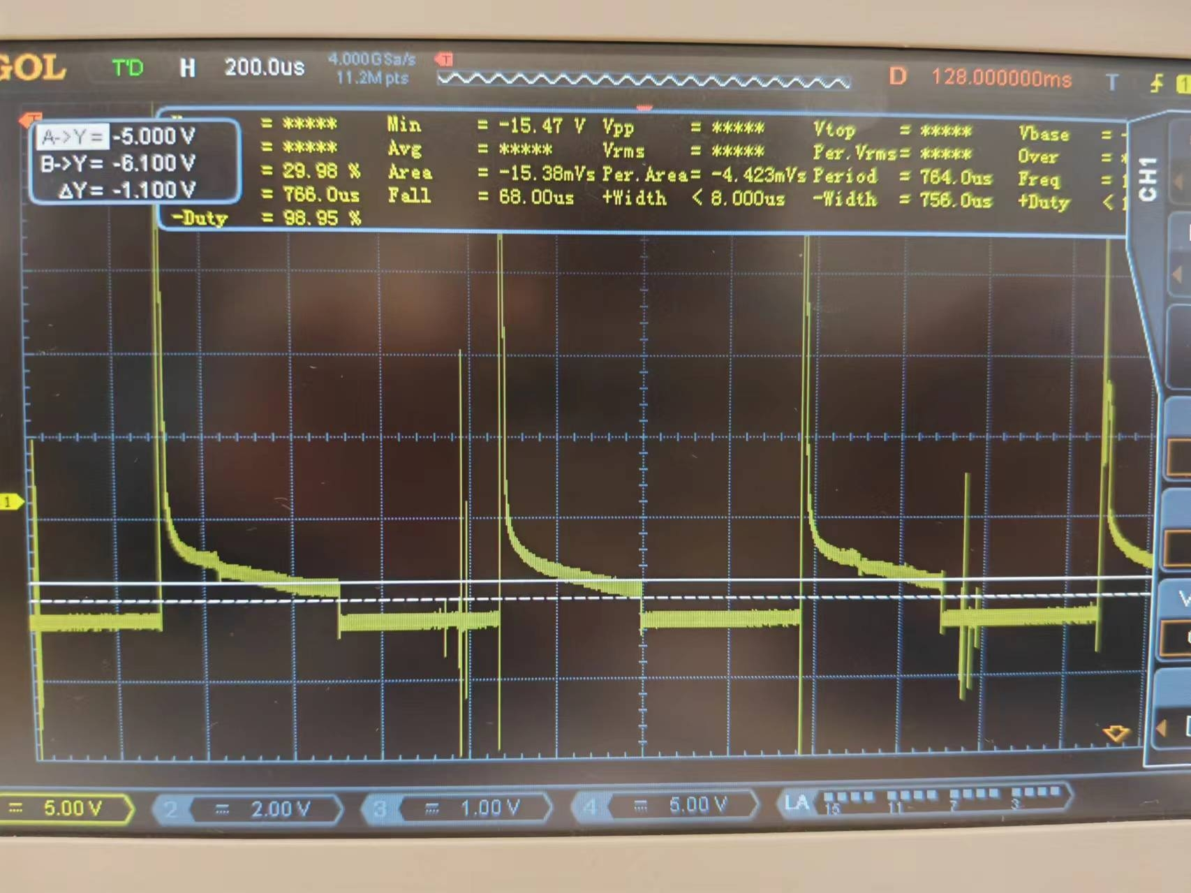

This large spike in vlotage can lead to motor damage. We can protect each motor by

placing a signal diode across each motor, like this:

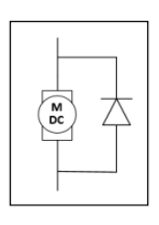

The diode connected in reverse parallel to the motor serves as a crucial component for mitigating the effects of back electromotive force or voltage spikes in the circuit. The diode provides a path for the current to circulate when the MOSFET is turned off, effectively creating a closed loop for the inductive current to flow.

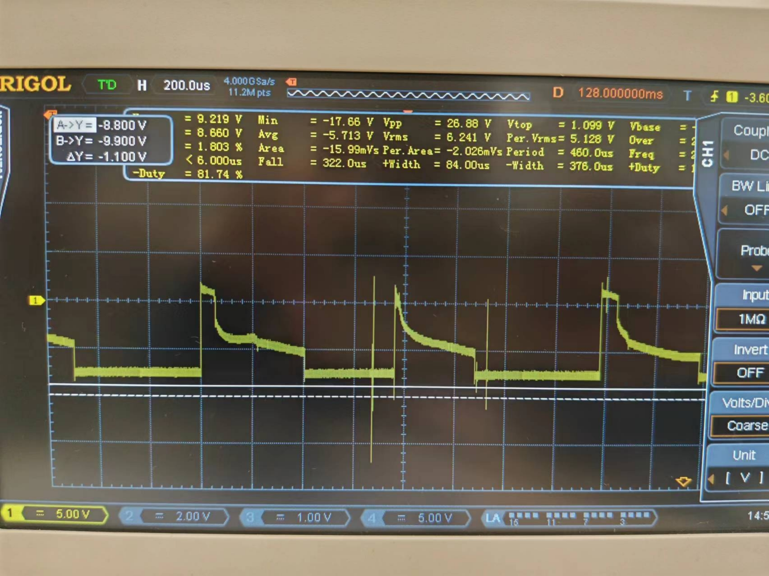

2 The issue of the earth ground connection of the oscilloscope

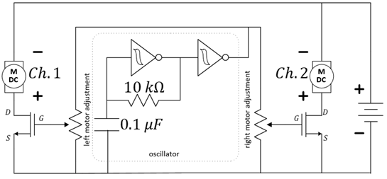

The negative electrodes of all measurement channels of the oscilloscope are internally connected to the ground.

1. Both ground leads connected to the positive battery terminal

Connecting both ground leads to the positive battery terminal effectively shifts the reference point of the oscilloscope to the positive battery potential. The oscilloscope will provide the reverse voltage wave of the motor.

1. Both ground leads connected to the MOSFET drains

Connecting both ground leads to the MOSFET drains sets the reference point of the oscilloscope to the MOSFET drain potential. the oscilloscope will provide the exact voltage wave of the motor

1. One ground lead connected to the positive battery terminal, the other ground lead connected to a MOSFET drain

This could create a short circuit between these two points, potentially damaging the circuit and the oscilloscope.

3 Pulse width modulation control of our motors

In PWM control of motors, the average voltage applied to motor is varied by rapidly switching the power on and off. This is achieved by controlling the width of the pulses in a square wave signal determines the average voltage seen by the motor.

A higher duty cycle results in a higher average voltage, which leads to a faster motor speed. A low duty cycle cycle results in a lower average voltage, reducing the motor speed.

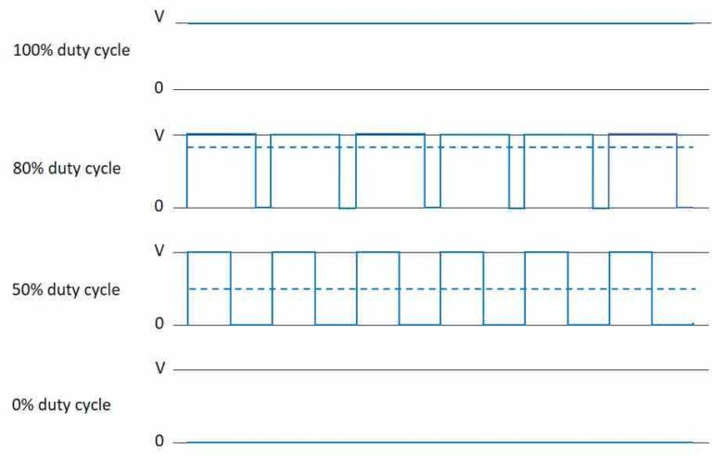

This method of control allows for precise and efficient regulation of motor speed without dissipating excessive power as heat, and offers a simple and effective means to achieve variable speed control.

4 The improved IV models of the motor

The Ohmic model assumes a constant resistance. The current is directly proportional to the voltage. It falls when describing the behavior of a complex system like a motor. There is difference in the ramp-up and ramp-down IV profiles. These are typically attributed to internal dynamics of the motor. During ramp-up, the motor accelerates from a stationary state, overcoming inertia, which may result in higher current draw. As the speed increases, factors such as internal resistance and other motor characteristics can lead to a gradual decrease in current. Conversely, during ramp-down, the motor decelerates from a higher speed, and the energy stored within its components can influence the current response, leading to a different IV profile compared to ramp-up.

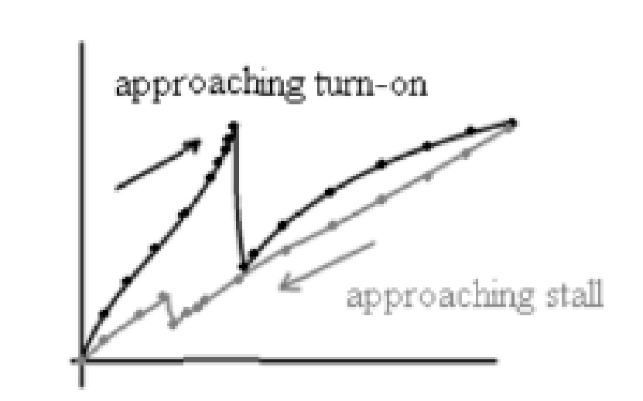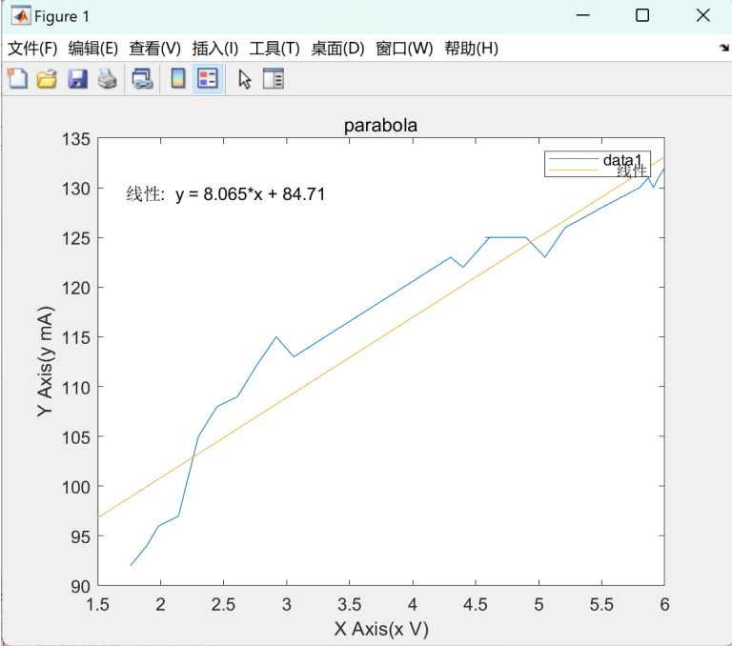

5 The role of buffer circuits

Buffers we used in the experiment 8 is a not gate

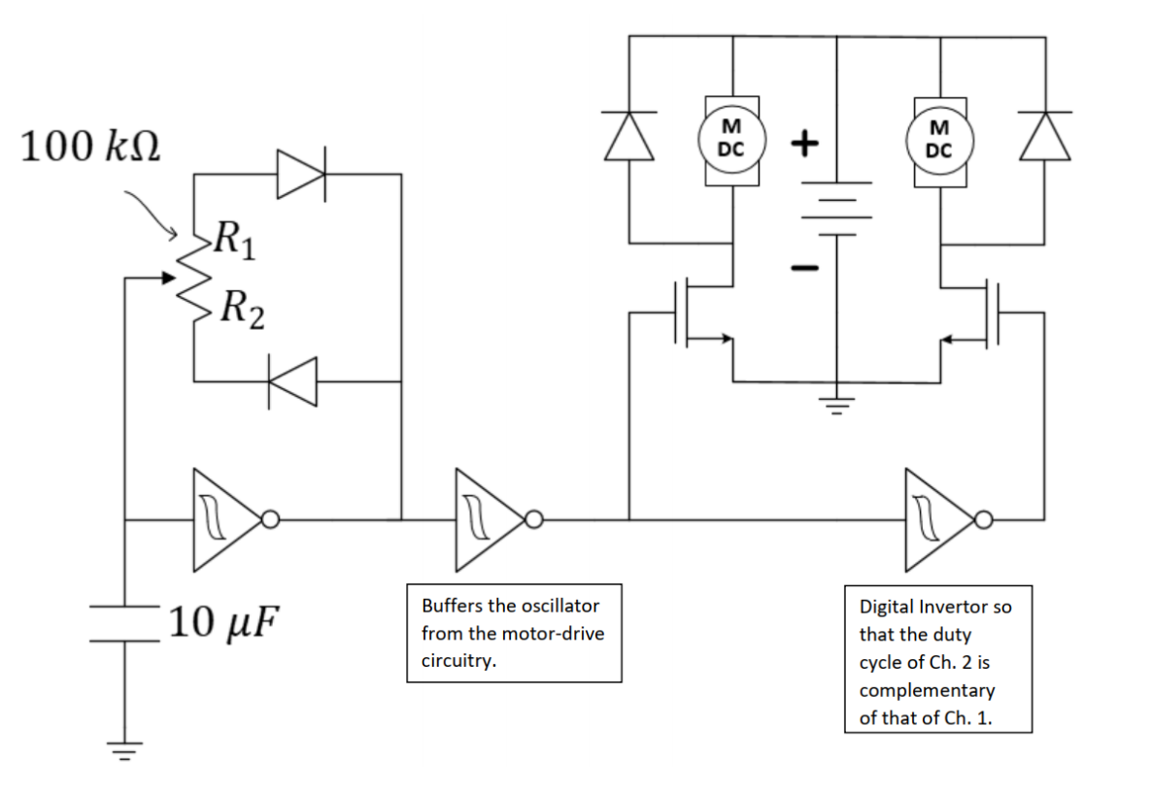

Why we use it:

Buffers are employed to isolate different sections of the system, effectively preventing unwanted interactions between signals.

Signal Integrity: They help maintain signal integrity by preventing the original signal from being distorted or attenuated as it passes through various stages.

What will happen if we don’t use it:

1 Increased risk of device damage

2 Reduced system stability: The buffer circuit also helps suppress noise from other circuits, ensuring signal stability

3 Without a buffer circuit to limit the overlap of voltage and current, switching losses can increase significantly, affecting the overall efficiency of the circuit.